CB.EN.U4CSE19063

ADVANCE PROGRAMMING

1) Write a program in C++ to print a welcome text in a separate line.

#include <iostream>

using namespace std;

int main()

{

cout <<"Welcome to \nAdvance Programming" << endl;

return 0;

}

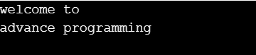

2) Write a program in C++ to print the sum of two numbers.

#include <iostream>

using namespace std;

int main()

{

cout <<"The sum of 29 and 30 is " <<29+30<< endl;

return 0;

}



3) Write a program in C++ to find Size of fundamental data types

#include <iostream>

using namespace std;

int main()

{

cout << " The sizeof(char) is : " << sizeof(char) << " bytes \n" ;

cout << " The sizeof(short) is : " << sizeof(short) << " bytes \n" ;

cout << " The sizeof(int) is : " << sizeof(int) << " bytes \n" ;

cout << " The sizeof(long) is : " << sizeof(long) << " bytes \n" ;

cout << " The sizeof(long long) is : " << sizeof(long long) << " bytes \n";

cout << " The sizeof(float) is : " << sizeof(float) << " bytes \n" ;

cout << " The sizeof(double) is : " << sizeof(double) << " bytes \n";

cout << " The sizeof(long double) is : " << sizeof(long double) << " bytes \n";

cout << " The sizeof(bool) is : " << sizeof(bool) << " bytes \n\n";

return 0;

}

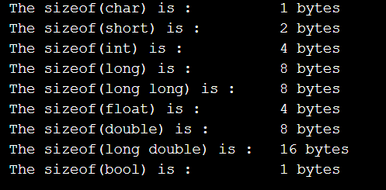

4) Write a program in C++ to print the sum of two numbers using variables

#include <iostream>

using namespace std;

int main()

{

int a,b,c;

cout<<"enter the first num to be added\n";

cin>>a;

cout<<"enter the second num to be added\n";

cin>>b;

c=a+b;

cout<<"the sum of "<<a<<" and "<<b<<" is "<<c;

return 0;

}

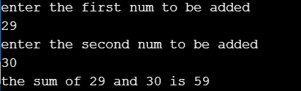

5) Write a program in C++ to check the upper and lower limits of integer

#include <iostream>

#include <climits>

using namespace std;

int main()

{

cout << " The maximum limit of int data type : " << INT_MAX << endl;

cout << " The minimum limit of int data type : " << INT_MIN << endl;

cout << " The maximum limit of unsigned int data type : " << UINT_MAX << endl;

cout << " The maximum limit of long long data type : " << LLONG_MAX << endl;

cout << " The minimum limit of long long data type : " << LLONG_MIN << endl;

cout << " The maximum limit of unsigned long long data type : " << ULLONG_MAX << endl;

cout << " The Bits contain in char data type : " << CHAR_BIT << endl;

cout << " The maximum limit of char data type : " << CHAR_MAX << endl;

cout << " The minimum limit of char data type : " << CHAR_MIN << endl;

cout << " The maximum limit of signed char data type : " << SCHAR_MAX << endl;

cout << " The minimum limit of signed char data type : " << SCHAR_MIN << endl;

cout << " The maximum limit of unsigned char data type : " << UCHAR_MAX << endl;

cout << " The minimum limit of short data type : " << SHRT_MIN << endl;

cout << " The maximum limit of short data type : " << SHRT_MAX << endl;

cout << " The maximum limit of unsigned short data type : " << USHRT_MAX << endl;

return 0;

}

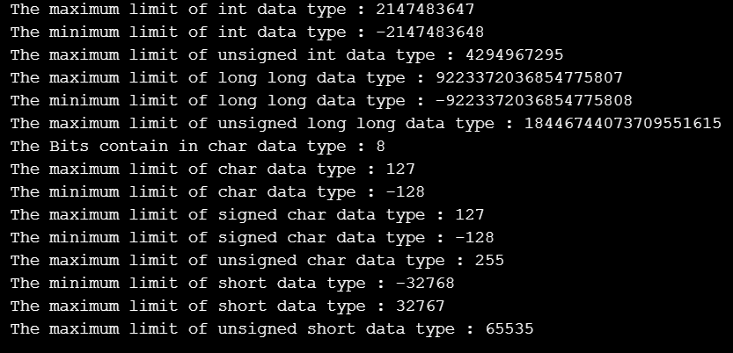

7) Write a program in C++ to display various type or arithmetic operation using mixed data type

#include <iostream>

using namespace std;

int main()

{

int m1 = 5, m2 = 7;

double d1 = 3.7, d2 = 8.0;

cout <<" "<< m1 << " + " << m2 << " = " << m1+m2 << endl;

cout <<" "<< d1 << " + " << d2 << " = " << d1+d2 << endl;

cout <<" "<< m1 << " + " << d2 << " = " << m1+d2 << endl;

cout <<" "<< m1 << " - " << m2 << " = " << m1-m2 << endl;

cout <<" "<< d1 << " - " << d2 << " = " << d1-d2 << endl;

cout <<" "<< m1 << " - " << d2 << " = " << m1-d2 << endl;

cout <<" "<< m1 << " * " << m2 << " = " << m1*m2 << endl;

cout <<" "<< d1 << " * " << d2 << " = " << d1*d2 << endl;

cout <<" "<< m1 << " * " << d2 << " = " << m1*d2 << endl;

cout <<" "<< m1 << " / " << m2 << " = " << m1/m2 << endl;

cout <<" "<< d1 << " / " << d2 << " = " << d1/d2 << endl;

cout <<" "<< m1 << " / " << d2 << " = " << m1/d2 << endl;

cout << endl;

return 0;

}

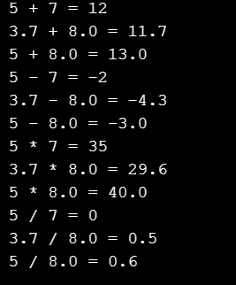

8) Write a program in C++ to check overflow/underflow during various arithmetical operation

#include <iostream>

#include <cstdio>

#include <cmath>

using namespace std;

int main()

{

int number;

/*Range of integers as given in the question : { -2147483648, 2147483647 } */

cout << "please enter a number out of this range : ";

cin >> number;

cout << number+1; // overflow shown

int number1;

cout << "please enter a number : ";

cin >> number1;

cout << number - 1; // underflow

return 0;

}

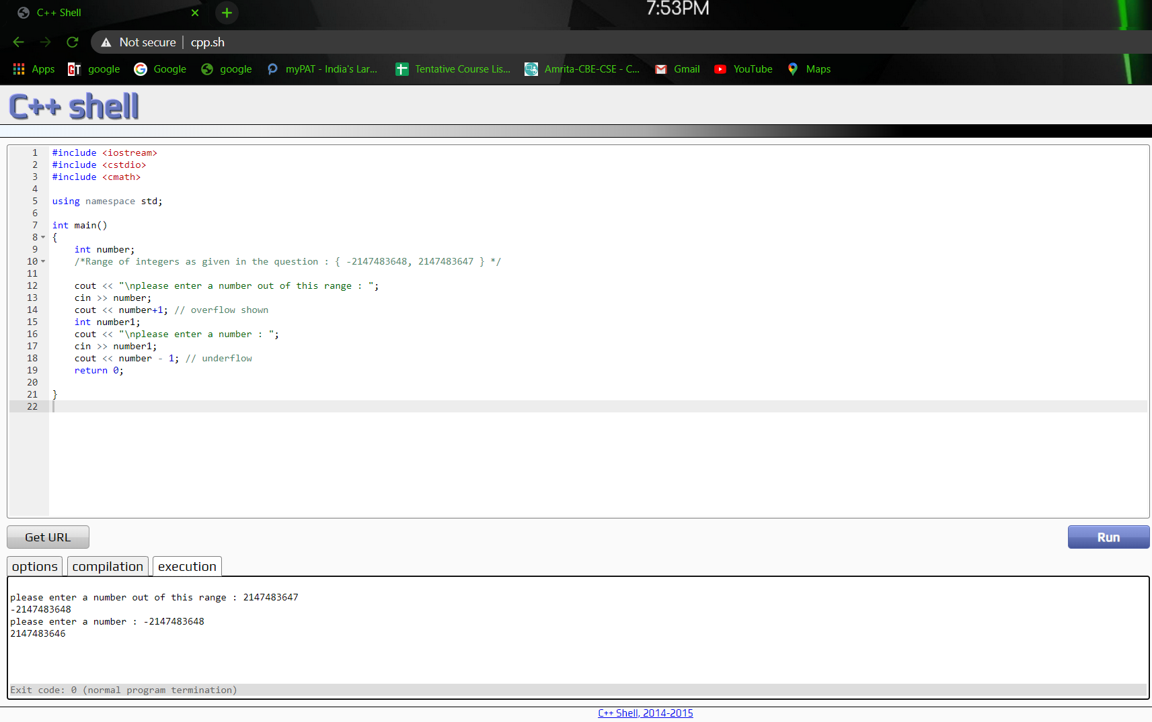

9) Write a program in C++ to display the operation of pre and post increment and decrement.

#include<iostream>

using namespace std;

int main()

{

int i;

cout<<"The number is :";

cin>>i;

cout<<"After post increment by 1 number is "<<endl;

++i;

cout<<i<<endl;

cout<<"After pre increment by 1 number is "<<endl;

i++;

cout<<i;

}

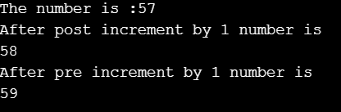

10) Write a program in C++ to swap two numbers

#include<iostream>

using namespace std;

int main()

{

int a=25;

int b=39;

int temp;

temp=a;

a=b;

b=temp;

cout <<"The first number is:"<<a<<endl<<"The second number is:"<<b;;

}



11) Write a program in C++ to calculate the volume of a sphere.

#include<iostream>

#include<iomanip>

using namespace std;

int main()

{

int r;

cout<<"Input the radius of sphere :";

cin >> r;

cout << "The volume of the sphere is : "<< (4/3)*(3.14)*r*r*r;

return 0;

}



12) Write a program in C++ to calculate the volume of a cube

#include<iostream>

using namespace std;

int main()

{

int r;

cout << "Input the side of cube :";

cin >>r;

cout<< "The volume of cube is :"<<r*r*r;

}



13) Write a program in C++ to calculate the volume of a cylinder

#include<iostream>

using namespace std;

int main()

{

int h,r;

cout<< "Input the radius of the cylinder :";

cin >>r;

cout << "Enter height of the cylinder : ";

cin >> h;

cout << "Volume of cylinder is :"<<3.14*r*r*h;

return 0;

}

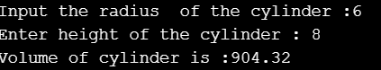

14) Write a program in C++ to find the Area and Perimeter of a Rectangle.

#include<iostream>

using namespace std;

int main()

{

int l;

int w;

cout <<"Enter the length of Rectangle :";

cin >> l;

cout << "Enter the width of Rectangle :";

cin >>w;

cout<< "Area of rectangle :"<<w*l<<endl<<"Perimeter of rectangle :"<<2*(l+w);

}

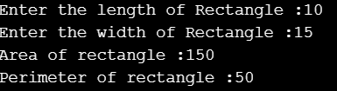

15) Write a program in C++ to compute quotient and remainder

#include<iostream>

using namespace std;

int main()

{

int div,d,r,q;

cout << "Input the divident :";

cin >> div;

cout <<"Input the divisor :";

cin >>d;

r=div%d;

q=div/d;

cout <<"Quotient is :"<<q<< "\nremainder is :"<<r<<endl;

return 0;

}

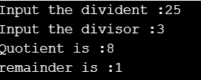

16) Write a program in C++ to input a single digit number and print a rectangular form of 4 columns and 6 rows.

#include <cstdio>

#include <iostream>

#include <cmath>

using namespace std;

int main()

{

char s;

int i,j;

cout << "please enter a number : ";

cin >> s;

for (i = 0 ; i < 6;i++)

{

for (j = 0; j < 4;j++)

{

cout << s ;

}

cout << "\n";

}

}

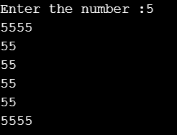

17) Write a program in C++ to check whether a number is positive, negative or zero

#include<iostream>

using namespace std;

int main()

{

int n;

cout << "enter the number :";

cin >> n;

if(n>0){

cout <<"The number is positive";

}

if(n==0)

{

cout<< "the number is zero";

}

if(n<0){

cout<<"the number is negative";

}

return 0;

}



**19)** Write a program in C++ to compute the specified expressions and print the output.

**#include <iostream>**

**using namespace std;**

**int main()**

**{**

**cout << " Result of the expression "<<"(25.5 * 3.5 - 3.5 * 3.5) / (40.5 - 4.5) is : "<< (25.5 * 3.5 - 3.5 * 3.5) / (40.5 - 4.5) <<"\n" ;**

**}**



**20)** Write a program in C++ to test the Type Casting ?

**#include <iostream>**

**#include <cstdio>**

**#include <cmath>**

**using namespace std;**

**int main()**

**{**

**int num1,num2;**

**cin >> num1 >> num2;**

**int sum = num1 / num2;**

**cout << sum << endl;**

**cout << float(num1/num2) << endl;**

**cout << float (num1) / num2 << endl;**

**cout << num1 / float(num2) << endl;**

**float num3,num4;**

**cin >> num3>>num4;**

**cout << int(num3)/num4<<endl;**

**cout << int (num3/num4) << endl;**

**num3 = num2;**

**cout << num3 << endl;**

**num2 = num3;**

**cout << num2 << endl;**

**}**

